# 发布

## 自动签名

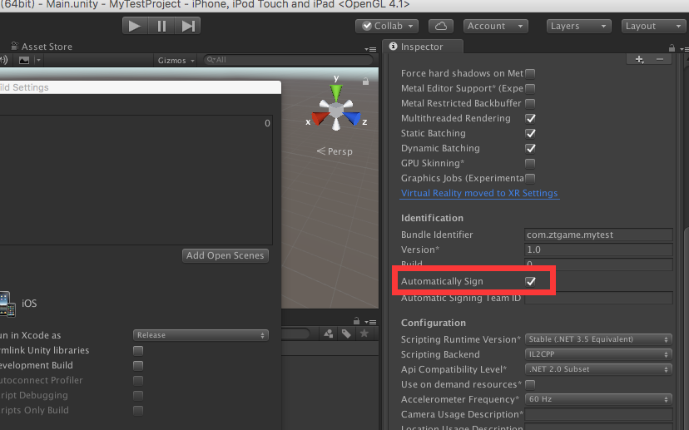

### Code Sign identity不见了。。。

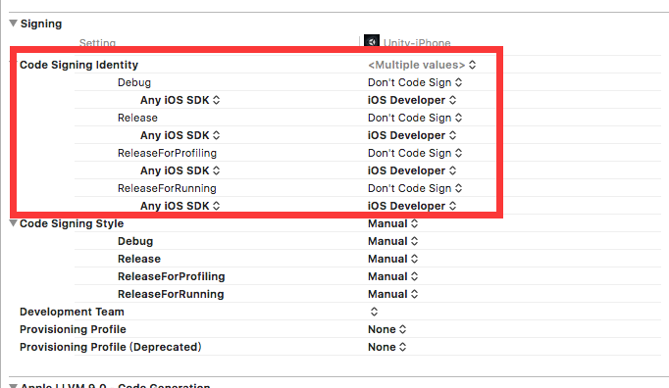

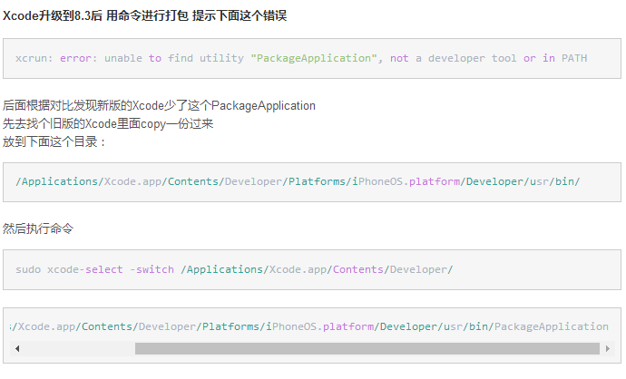

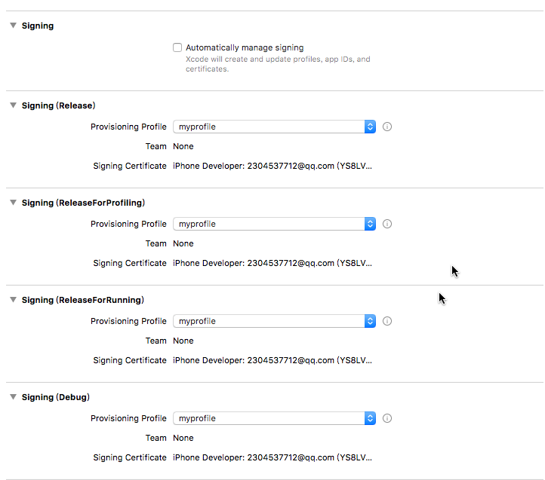

### xcrun: error: unable to find utility "PackageApplication", not a developer tool or in PATH

https://blog.csdn.net/itiapp_home/article/details/70241011

